**Credentials Storage User Provided Service**

Instead of storing the database credentials in an **application.propeties** file. I have created a user provided service in PCF where we can store all database or application credentials

**Service is create**

**User Provided Service Name**: Adsales_Credentials

I have configured database details in this service

PFA **dbconfig.json** file where the details about the database is mentioned



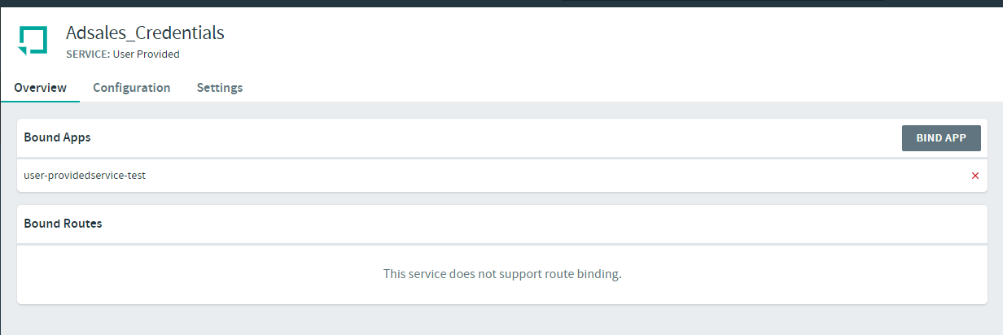

I have binded the application with the (**user-providedservice-test**) in that **application.properties** depends upon the profile it will take the properties from the user provided service

